**PROPERTY MANAGMENT APPLICATION USING SALESFORCE**

# **1. INTRODUTION**

**1.1 OVERVIEW**

**Property management is the daily oversight of residential, commercial or industrial real estate by a third – party constractor. Genarally,property managers take responsipility for day to day repairs and ongoing maintance security and upkeep of properties.**

**1.2 PURPOSE**

**Property managers assist owner in creating budget advertise rental properties, qualify, tenants and collect rent . They also comply with the logal landlord and real estate board laws and maintain the property**

# **2. PROBLEM DEFINITION & DESIGN THINGING**

**2.1 EMPATHY MAP**

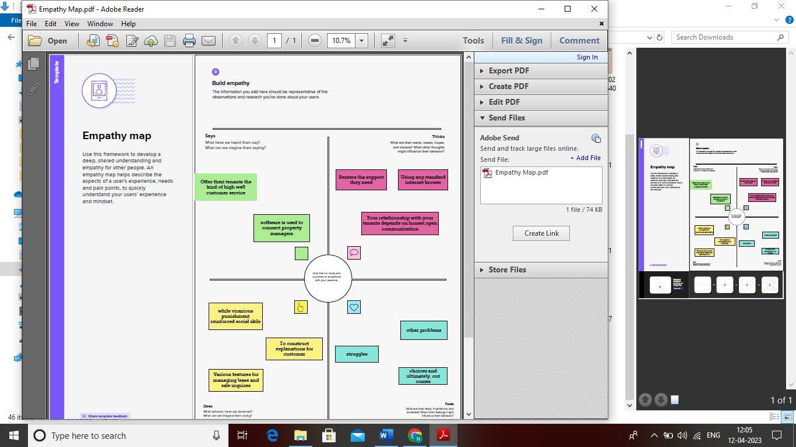

**2.2 IDEATION & BRAINSTORMING MAP**

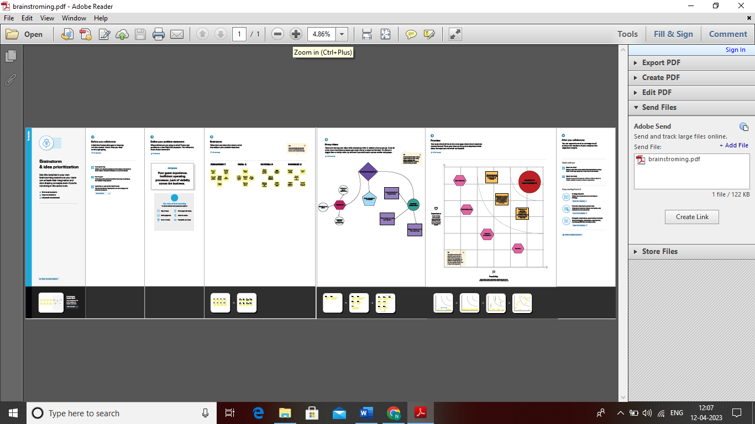

# **3. RESULT**

**3.1 DATA MODEL:**

|  |  |
| --- | --- |
| **OBJECT NAME** | **FIELDSS IN THE OBJECT** |
| **Object 1** | |  |  | | --- | --- | | **Field label** | **Data type** | | **Lead** | **Currency** | |
| **Object 2** | |  |  | | --- | --- | | **Field label** | **Data type** | | **Loan payment** | **Number** | |

**3.2 ACTIVITY & SCREENSHOT**

**Milestone(2)-Object**

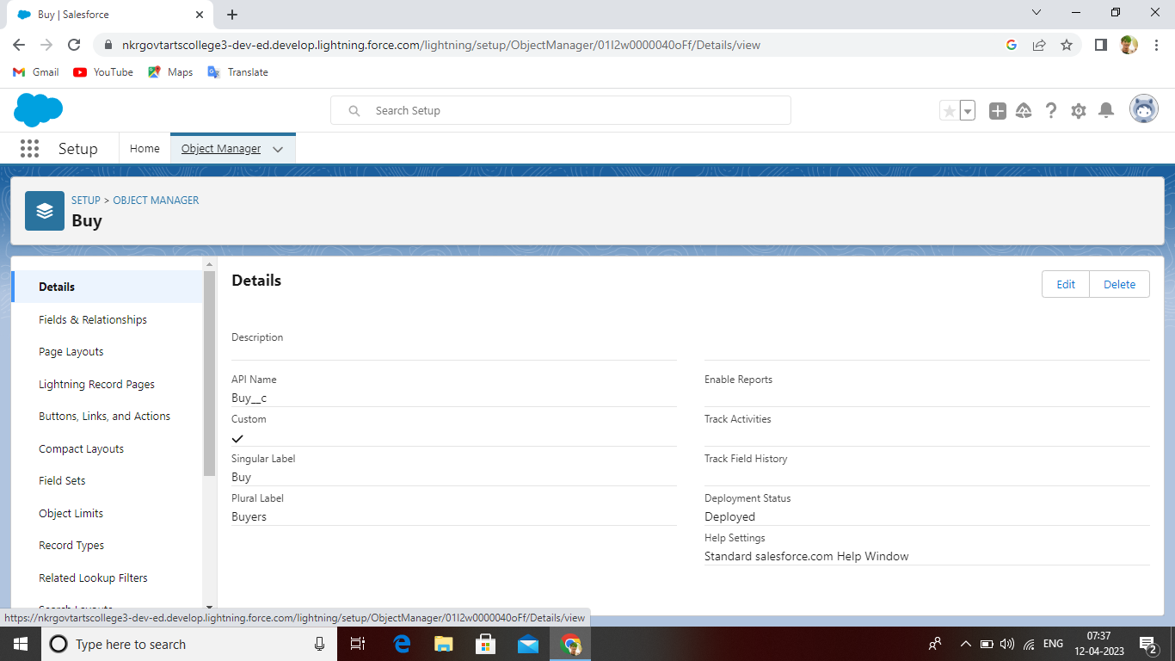

Milestone (3)-Tab

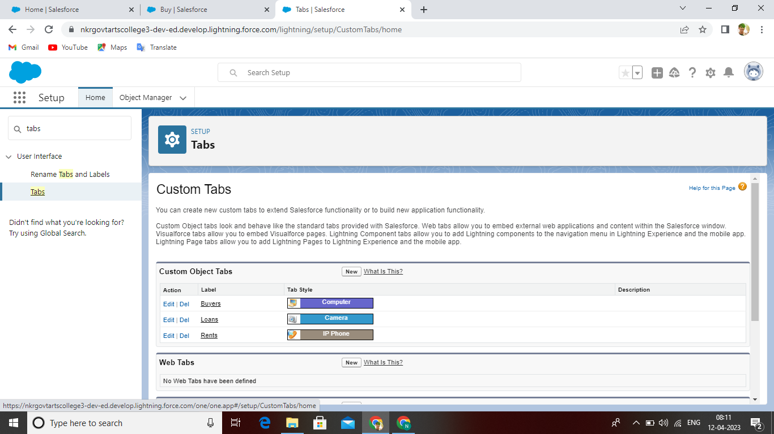

Milestone(4)-The Lighting App

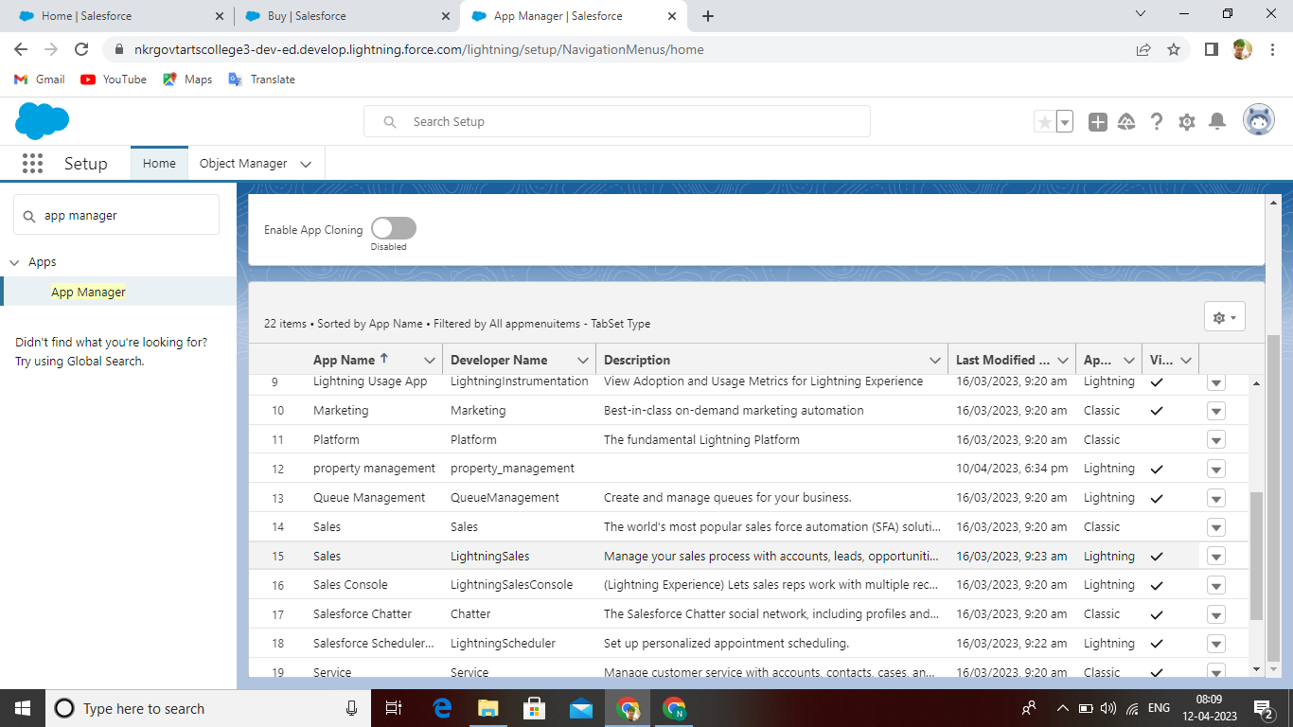

Milestone(5)-Fields

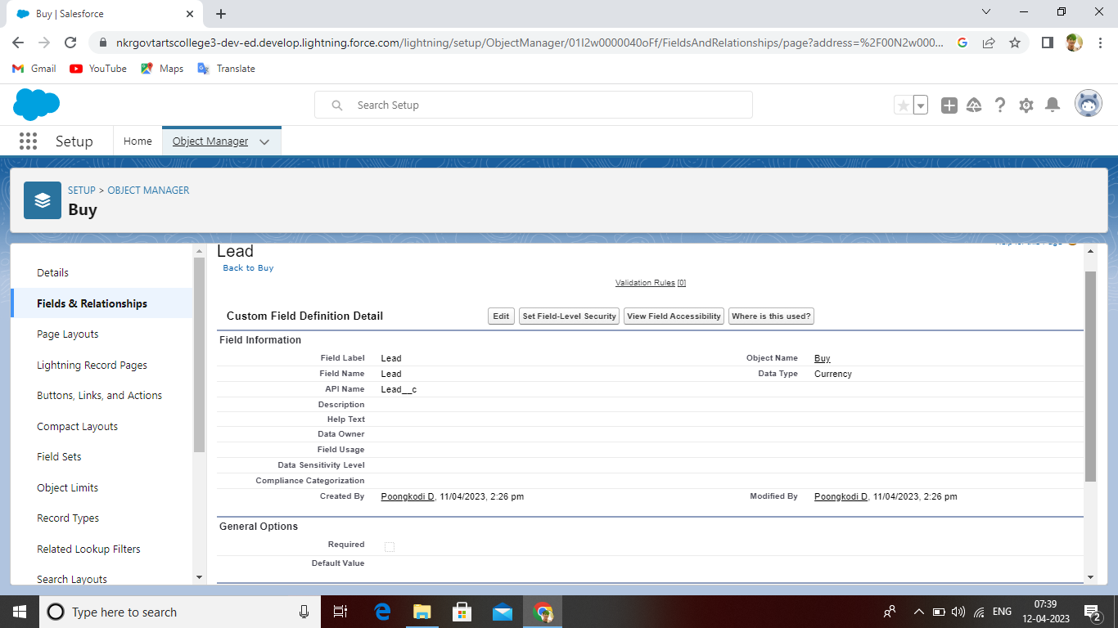

Milestone(6)-Profiles

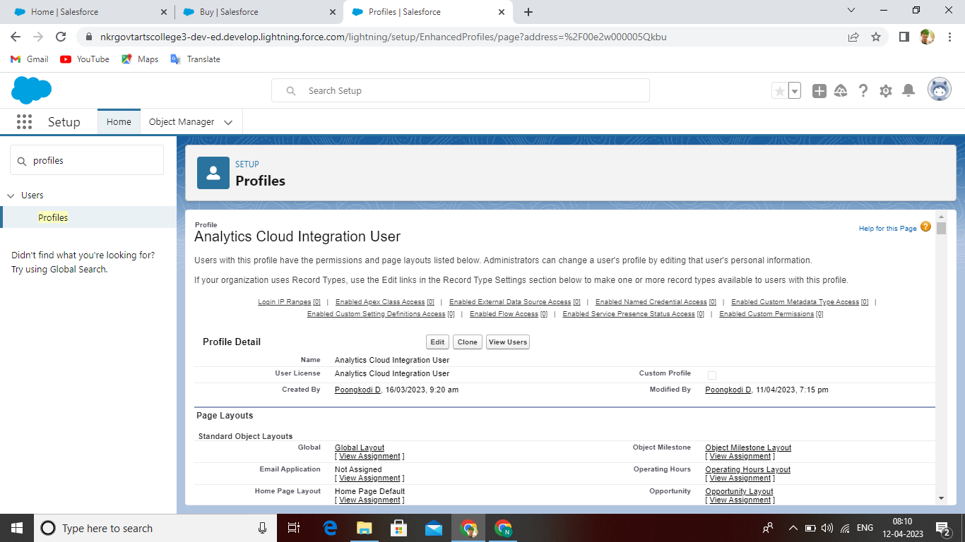

Milestone(7)-New User

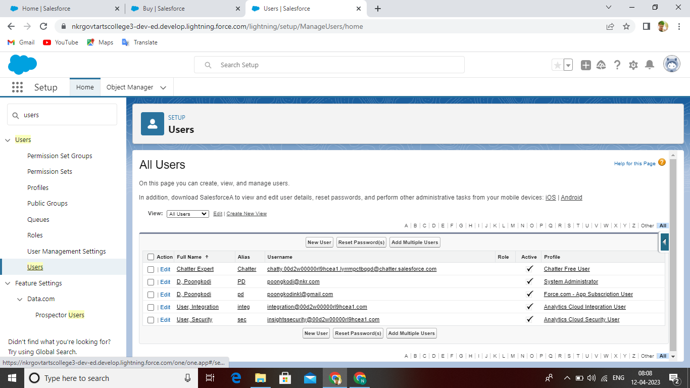

Milestone(8)-Permission Sets

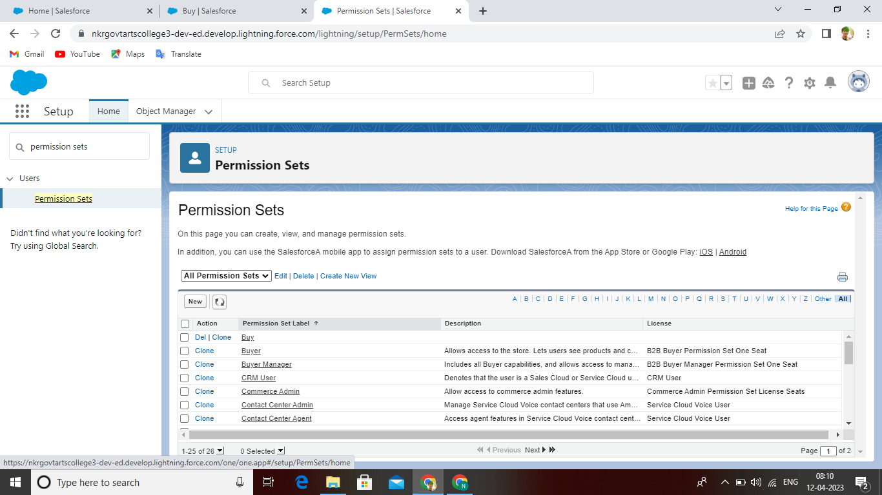

Milestone(9)-Setup For OWD

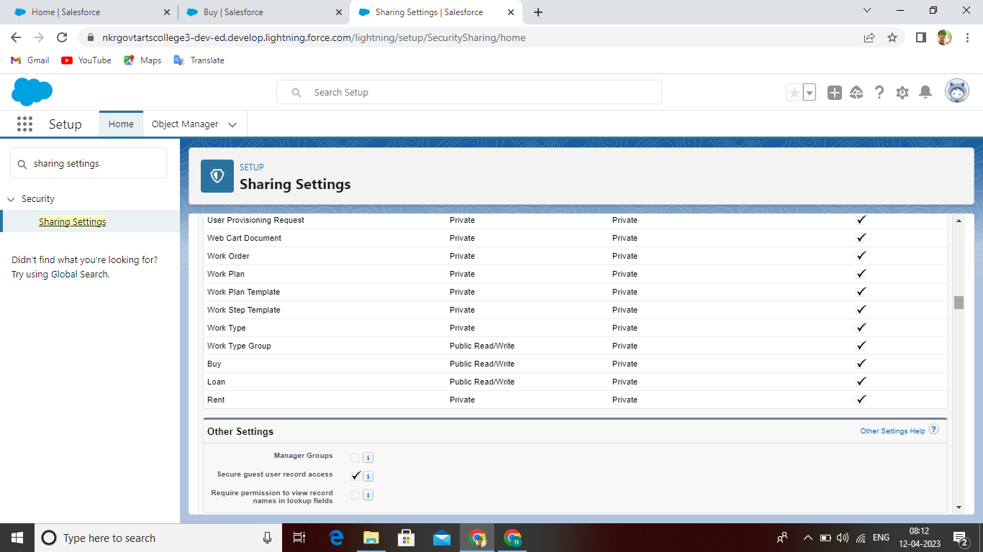

# **4. TRAILHEAD PROFILE PUBLIC URL**

**Team Lead-htpps://trailblazer.me/id/nisht58**

**Team Member1-htpps://trailblazer.me/id/nisha0510**

**Team Member2-htpps://trailblazer.me/id/pavin31**

**Team Member3-htpps://trailblazer.me/id/poond2**

# **5. ADVANTAGES**

* + Long lime tenants
  + More efficient reay colletion
  + Lower repair and maintenance costs
  + Increase & maintain the value of your rental property

# **DISADVANTAGES**

* + You have to pay for add on to get most out of the software
  + Configuration & setup is complex & time – consuming
  + The learning curve never seems to end
  + Constomer support as a poor reputation

# **6. APPLICATION**

* + A property management system is asoftware application for accommondation commercial residental rental propertys. PMS is also used manufacturing induestries, local government and manufacturing.

# **7. CONCULSION**

PMS provide a suite of services that can help firms moniter and optimize back office activites and finances and even enhance the security of their properties.

# **8. FUTURE SCHOPE**

Property management firms have no choice but to grow and advance their use of technology to fulfill clients demands and follow local regulations. Owner wish to see financial data on denand without going through the property manager all the time. They can do that with an owner portal.